BCS (BBN Branch) Cyber Challenge 2026
Schools are invited to introduce
the competition to students from Year 5 to Year 10

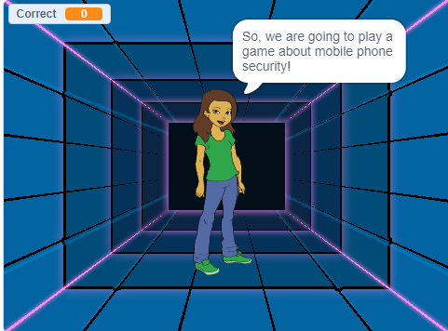
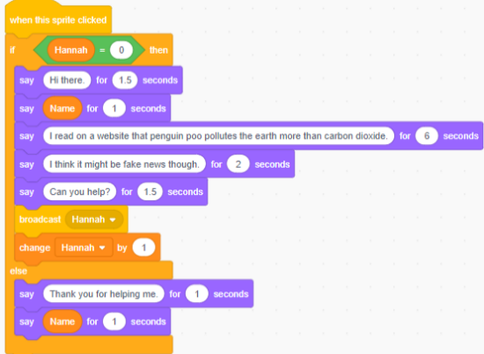
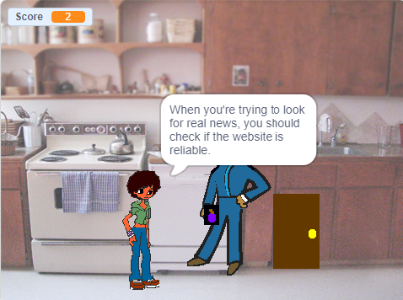
Since 2013, the BCS local Branch has been running a competition to cultivate young computing leaders. This is an excellent opportunity for coding clubs and projects for students in Maths and Computing classes.

Participating in the Cyber Challenge is a positive way to fulfil STEM Gatsby benchmarks like linking curriculum learning to careers, encounters with employers and employees, encounters with further and higher education.

The competition is open to all schools in the areas of Bedford Borough, Central Bedfordshire, Luton, Milton Keynes, Buckinghamshire, North and West Northamptonshire.
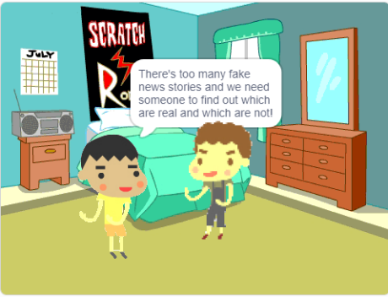
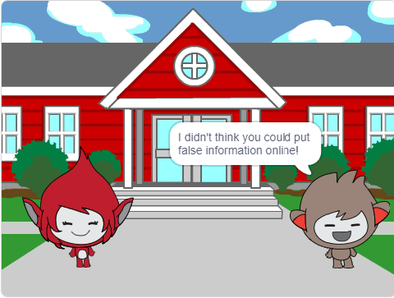
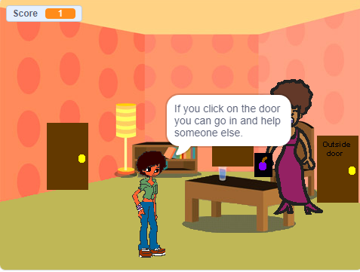

BCS, The Chartered Institute for IT, champions the global IT profession and the interests of individuals engaged in that profession for the benefit of all.

A unique opportunity to build up STEM whether students are studying in school or working from home


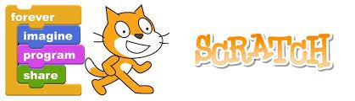


6 Competition Groups
Year 5 Online Safety
Create an educational resource that promotes the positive aspects of online talking and messaging but also helps people to understand when online behaviour could become inappropriate and risky. The resource must send out a safe online message so that people feel empowered to deal with uncomfortable situations online.

Year 6 Dealing with Cyberbullying
Create an educational resource that shows young people how to deal with Cyberbullying and what could be done to prevent it in the first place. The resource must send out a safe online message so that people feel empowered to deal with Cyberbullying in a safe and sensible way.

Year 7 Fake News
Create an educational resource that promotes the positive aspects of using online resources to learn, for schoolwork and social interactions, but also be careful to check if the information is true or false. The resource must encourage a behaviour of critical evaluation to get the best from online information and discard the fake.

Year 8 Identity Theft
Produce a game that helps people to understand what identity theft is and why it is important to guard against it. The game could help the players recognise strategies used to access private information. The game must suggest ways to guard against phishing and identify theft.

Year 9 Cryptocurrency
Cryptocurrency is digital money that uses blockchain technology for online payment. Some people earn a lot of money through investment in crypto, and some lost a lot. Crypto is also used for anonymous payments. Produce a game that is fun to play and informs the public about cryptocurrency and how to protect themselves or their businesses.

Year 10 Artificial Intelligence
Artificial Intelligence is available on computers and phones. It is a great information source and do tasks like writing, drawing diagrams and editing photos. Produce a game that helps students to understand what are the positive ways to use Artificial Intelligence for study, and how to avoid AI use that can cause problems for students in school.

Competition Rules:
- Students may work individually, in pairs or teams of no more than 4.
- Participants are students from year 5 to 10 and they enter the competition according to their year group. Students submit through the responsible schoolteacher.
- Students can use Scratch, Kodu, EduBlocks, or ANY suitable programming language.
- Please register your interest by email to: bbnbr@bcs.co.uk. This will greatly help our preparation logistics.
- The deadline for submission is 12th June 2026.
- Students are reminded to be e-aware and avoid music or images that are subject to copyright restrictions.
- All work must be original and done with minimal help of teachers or parents. Help given must be notified on the entry form.
- During the production students should follow the normal rules of safety and not reveal any personal details online (e.g. Scratch) and all work should be polite and respectful.
- The judges’ decision is final.
- This competition is open to all local education authorities funded and independent schools in Bedford Borough, Central Bedfordshire, Luton Borough, Milton Keynes and Buckinghamshire, North and West Northamptonshire.
Prizes to include: Trophies, medals and other goodies, these will be awarded at Cranfield University in 30 June 2026.

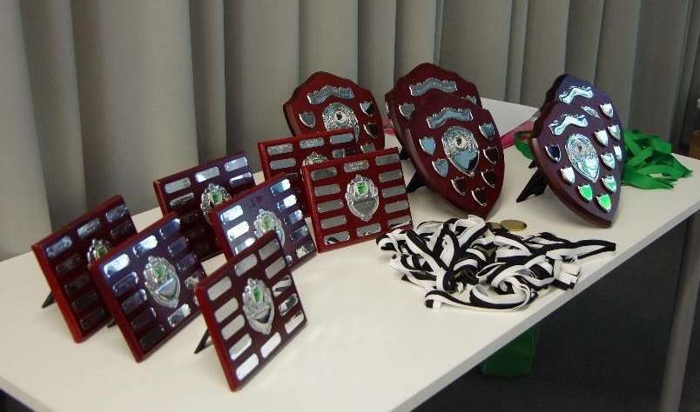
Judges will be looking for:
- Creativity
- Selection use, combination and presentation of images and text
- The appropriate choice and use of programming instructions and should include: Custom blocks, Loops and Variables
- The clarity of the finished presentation in demonstrating improved learning outcomes
For further information please contact: bbnbr@bcs.co.uk
Useful Resources
Scratch
https://scratch.mit.edu/

Kodu
https://www.kodugamelab.com/

Alice – Tell Stories. Build Games. Learn to Program
www.alice.org

EduBlocks - Making the transition from Blocks to Python easier
https://edublocks.org/

Python Tutorial
https://www.w3schools.com/python/

Java Tutorial
https://www.w3schools.com/java/

Purple Mash
https://www.purplemash.com/

Python in Pieces
https://pythoninpieces.com/
If your school doesn’t currently have a subscription to Purple Mash or Python in Pieces, please contact georgia@2simple.com for free access

Computing at School
https://community.computingatschool.org.uk/

Barefoot Computing
https://www.barefootcomputing.org/homelearning

BCS Academy of Computing
https://www.bcs.org/more/bcs-academy-of-computing/

