**BCS (BBN Branch)** **Cyber Challenge**

**Prize Presentation**

Over 100 students, teachers and parents attended the 2025 Cyber Challenge competition prize presentation at the Digital Aviation Research and Technology Centre at Cranfield University on 3 July 2025.

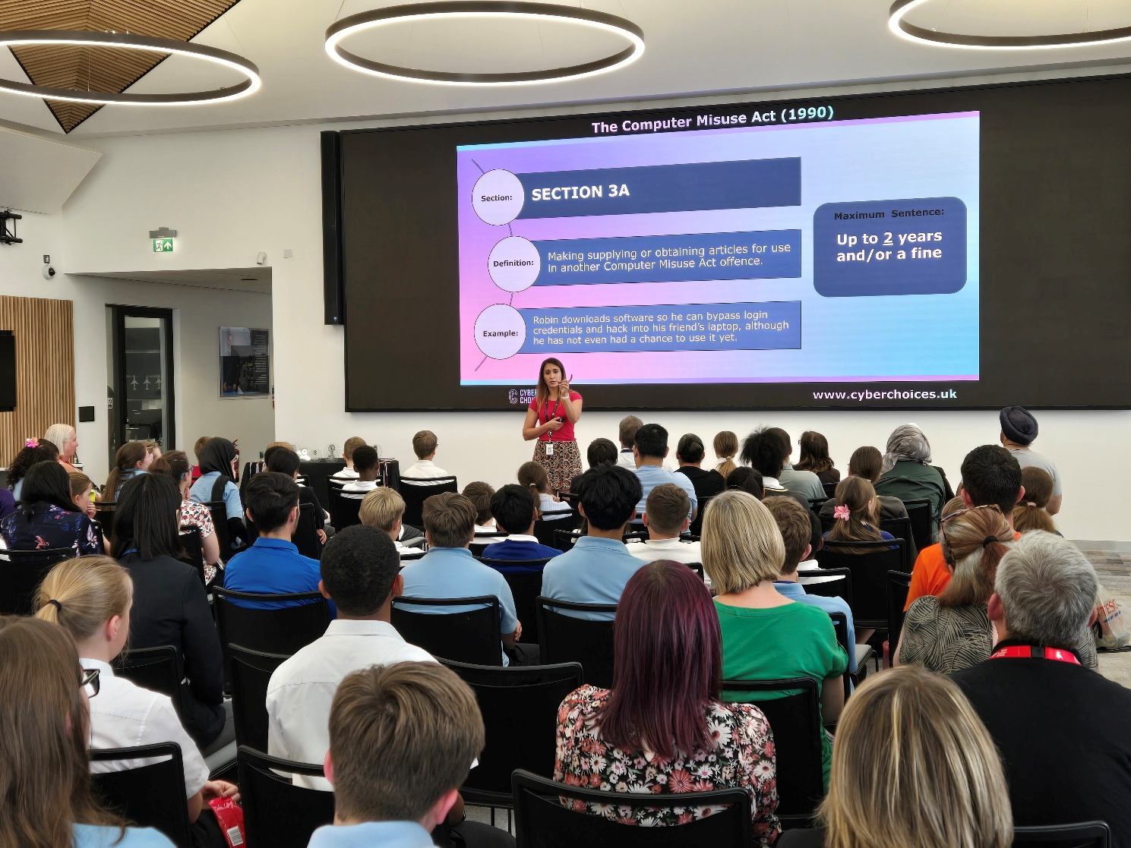

Selected quality entries were shown off to inspire the future computing leaders. Veri Granger from the Bedfordshire Police reinforced the message of CyberChoices.

Since 2013, the BCS Bedford Branch has been running a competition to cultivate young computing leaders. The competition is open to all Year 5 to Year 10 students from schools in the areas of Bedford Borough, Central Bedfordshire, Luton, Milton Keynes, Buckinghamshire, North and West Northamptonshire.

The judges were looking for:

* Creativity
* Selection use, combination and presentation of images and text
* The appropriate choice and use of programming instructions and should include Custom blocks, Loops and Variables
* The clarity of the finished presentation in demonstrating improved learning outcomes

The submission quality is very high, and the judging panel had to make difficult choices.

The award winners are:

|  |  |  |  |
| --- | --- | --- | --- |
|  | **First** | **Second** | **Third** |
| **Year 5** | Astrid  *Spratton Hall* | Caitlin, Isla, Chloe  *Leighton Middle* | Alex, Ishantha, Oliver *Swanbourne CE* |
| **Year 6** | Elliot  *Hills Academy* | Phoenix  *Tylers Green Middle* | Rafe  *Hills Academy* |
| **Year 7** | Amiya  *Bosworth Independent* | Theo  *Putteridge High* | Xanda  *Bosworth Independent* |
| **Year 8** | Amelia  *Putteridge High* | Jennifer  *Chiltern Academy* | Danvika  *Royal Latin* |
| **Year 9** | Steven  *Mark Rutherford* | Sameer, Riley  *Lea Manor High* | Oliver  *Mark Rutherford* |
| **Year 10** | Tahir, Raphael  *Lea Manor High* | Thomas, Riley, Wali *Lea Manor High* |  |

After the prizes were presented, the visitors toured the Cranfield 737 Ground Demonstrator.



The BBN Branch committee congratulates the students, their teachers and parents who supported them. We look forward to seeing them again at the 2026 competition.

Dr Ip-Shing Fan, chair of the BCS BBN Branch said: “There’s a huge computing skills shortage in the UK and this competition aims to inspire young people to think about careers in IT, by developing their skills. We work with the teachers support networks to improve the computing learning experience in our local schools.”