

A British Computer Society (Bedford branch) Event at the Park Inn, Bedford

Date: Wednesday, 7 October 2015

Topic: ”Smart Phone Security – What is Phone Hacking?”

Speaker: Geraint Williams, Information Risk Consultant and Trainer, IT Governance Ltd.

Time: 6.30-8.00pm; registration starts at 6:00pm

Location: Bridge Suite, The Park Inn, 2 St Mary's Street, Bedford MK42 0AR

Register online at:
https://events.bcs.org/book/1729
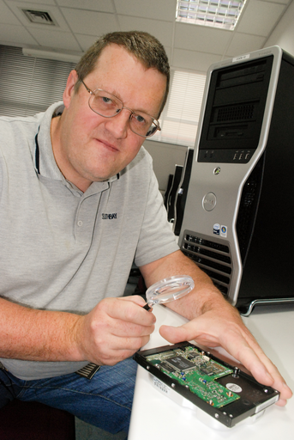
You are warmly invited to attend a FREE evening talk at The Park Inn, Bedford (opposite Bedford College) on Wednesday 7 October 2015.

”Smart Phone Security – What is Phone Hacking?” is the topic of a talk and demonstration by Geraint Williams, Information Risk Consultant and Trainer, IT Governance Ltd.

Geraint’s talk will cover the following topics:
- Voice mail hacking
- Mobile phone network hacking
- Insecure wifi usage
- Smart phone app security

Geraint Williams is an Information Risk Consultant and Trainer for IT Governance Ltd. Geraint is a knowledgeable and experienced Information Security consultant with experience including vulnerability testing, digital forensics, secure networking, and wireless security issues. Geraint has a strong technical knowledge of security and IT infrastructure including high performance computing. Geraint has a number of certifications in security and digital forensics including CISSP, CISA, CEH and CHFI and is a Qualified Security Assessor for the Payment Card Industry (PCI).

Agenda

6.00pm Registration, refreshments and networking

6.30pm Introduction
”Smart Phone Security – What is Phone Hacking?”

7.20pm Opportunity to question the speaker

7.45pm Thanks
Opportunity to network and talk to the speaker

There is free parking to the rear of The Park Inn. Parking spaces are also available at a £1 charge on the Bedford College Campus.

Everybody is welcome – please bring friends and colleagues.

Register online at:
https://events.bcs.org/book/1729

